**9-12-23 notes**

Data Fundamentals in Excel

Module 1.2 goals:

* Explain the benefits of using pivot tables.
* Generate and interpret pivot tables.
* Use VLOOKUPs and HLOOKUPs.
* Implement conditional formatting based on logical rules.

Review:

No external bias or variance in the analysis!

Analytics Paradigm:

* Decompose the Ask
* ID data sources
* Define strategy and metrics
* Build data retrieval plan
* Retrieve the data
* Assemble and clean
* Analyze for trends
* Acknowledge limitations
* Make the call/Tell the story

Excel uses ‘Functions’





^Excel requires full word “Average”



^Nested functions

You can also highlight cells, and name the range in the upper left corner where it says the cell name.

IE: First “Semester” instead of B2:B19

**Conditionals:**

If, Then, Else statements

IE: =if (d2>5, “True”,”False”)

And, Not, Or statements



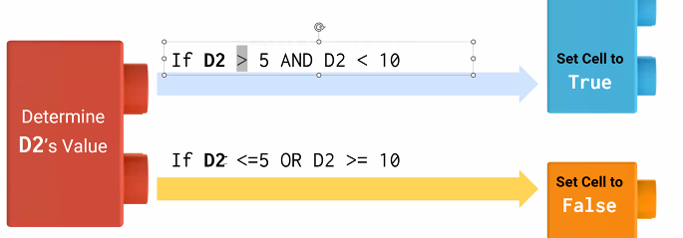

IFS function is easier than nesting If functions

Function



Result in Excel, with conditional formatting:

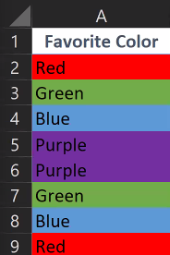

Countif function



Range of cells A2:A20 is called Colors

And function



https://support.microsoft.com/en-gb/office/using-if-with-and-or-and-not-functions-d895f58c-b36c-419e-b1f2-5c193a236d97

Sumif Function

**Measures of Central Tendency:**

Mean- Average

Median- Middle value

Mode- Value that appears most

$A1 🡨 Dollar sign is an absolute reference to a cell. Guarantees that it won’t move the cell the function refers to if you drag a formula down a row

**Formatting in Excel:**

Data formatting:

Changes the way a value is represented

* Examples: Date and time, currency, percentages, scientific notation, etc
  + Excel stores dates as a number

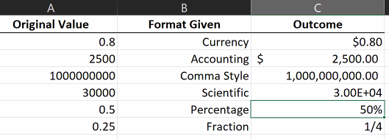

Style formatting:

Changing font, background fill, etc…

**Pivot Tables**

Insert, Pivot table, (excel automatically has it set to select the range and open table in a new tab)

To sort, Right click a value in a cell

∑ Values box (Lower right box in pivot table field list) will get the sum of values, or the count

**Horizontal and Vertical lookups**

HLOOKUP and VLOOKUP

Use the  button to the left of the cell contents box to open function arguments box (for help filling in the formula)

=VLOOKUP(Lookup_value, Table_array, Col_index_num, Range_lookup)

Lookup_value: the value that appears in the other table

Table_array: where the lookup is looking

Col_index_num: Which column’s data to pull back

Range_lookup: select either True/False

XLOOKUP is also an option

It’s newer, so a lot of people are used to VLOOKUP or HLOOKUP

